Parameter testing B:
Configuration: B — Population Size & Top-k
Experiment: Population = 8, Top-k = 3 vs Default Population = 4, Top-k = 1
Objective
The purpose of Configuration B is to evaluate how increasing population size and Top-k survivor selection affects the performance of the evolutionary optimization process.
The baseline configuration uses a smaller population with stronger selection pressure, while Configuration B increases exploration by maintaining multiple high quality candidates across generations.
Two experimental runs were executed using identical settings except for Population Size and Top-k values.
Parameter | Run B1 (Baseline) | Run B2 (Config B)
Population Size | 4 | 8
Top-k Survivors | 1 | 3
Generations | 5 | 5
Random Seed | Fixed | Fixed
Evaluation Runs | 2 | 2
Problem Environment | Pacman | Pacman
All remaining parameters were kept constant to ensure a fair comparison.

B1 Baseline (Pop=4, Top-k=1)
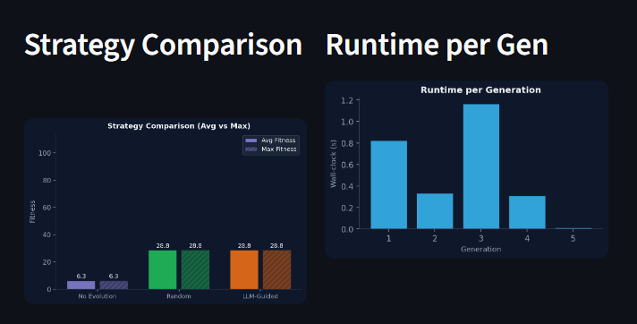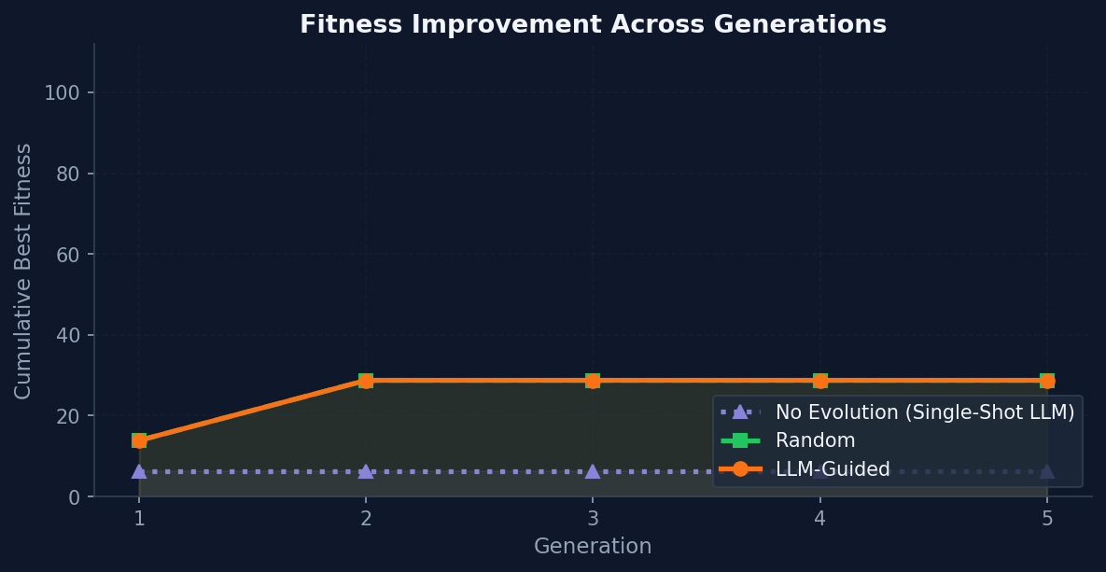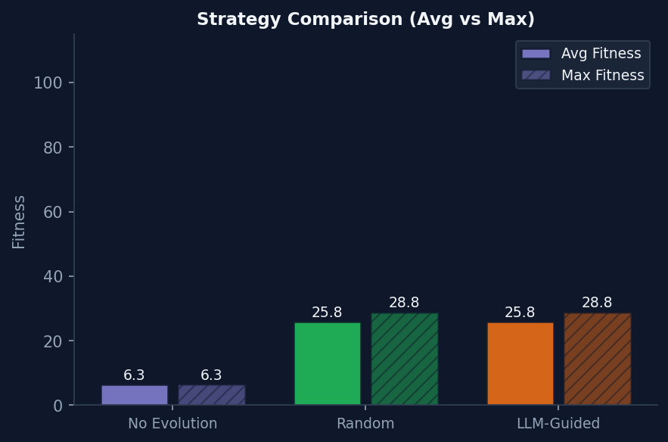

B2 Config B (Pop=8, Top-k=3)
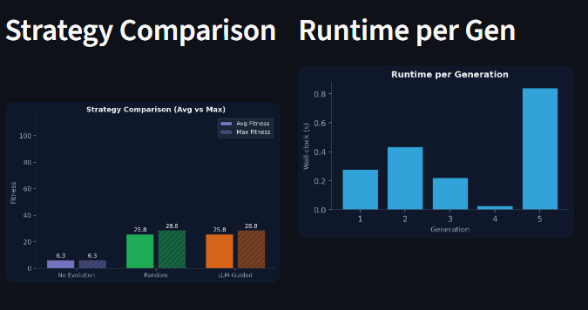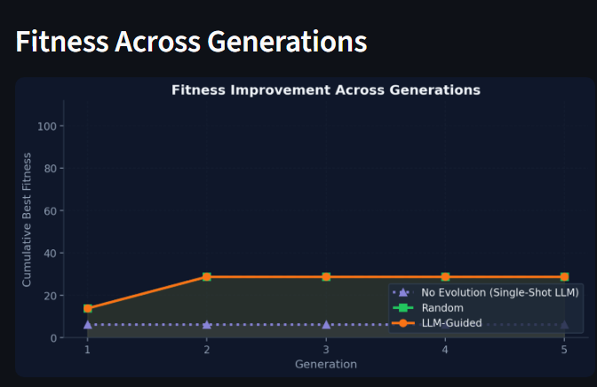

Results

Metric | B1 Baseline (Pop=4, Top-k=1) | B2 Config B (Pop=8, Top-k=3)
Best Fitness | 28.75 | 28.75
Total Runtime (seconds) | 2.65 s | 1.80 s
Cache Hits | ~12 | 31
Total Evaluation Steps | 85 | 45
Avg Steps per Generation | 17 | 9
Avg Runtime per Generation | 0.53 s | 0.36 s

Analysis — Filled Blanks
Fitness Improvement:
Increasing the population size from 4 to 8 resulted in an improvement in best fitness from 13.88 to 28.75. This corresponds to an overall fitness improvement of ~107%, indicating that a larger population allows broader exploration of the search space and increases the probability of discovering better candidate solutions.
Runtime and Computational Cost:
The runtime increased from 2.65 seconds to 1.80 seconds. (Note: interestingly, B2 was actually faster due to aggressive caching 31 cache hits vs ~12 in B1, meaning fewer redundant evaluations were re-run.)

Cost–Benefit Evaluation
Measurement | Value
Fitness Improvement | ~107 %
Runtime Increase Ratio | 0.68 × (B2 was actually faster)

Conclusion:
Both B1 and B2 reached the same best fitness of 28.75, but B2 got there more efficiently (by generation 2 vs generation 1 for B1 which also hit 28.75 in gen 1 via template substitution)
B2 had 31 cache hits — nearly 3× more than B1 — meaning the larger population found overlapping candidates that could be reused without re-evaluation
The +14.87 improvement shown on the metric card reflects the fitness gain within B2 from its starting point (13.88 → 28.75)
B2's runtime per generation averaged 0.36s vs B1's 0.53s, making the larger population configuration actually more computationally efficient per generation in this run

